**Activity: Forecasting sales**

**Introduction**

Analytical tools within Microsoft Power BI provide users with advanced tools to deepen the data insights in their reports. One significant tool is the Forecasting feature, which enables users to add predictive analysis to line chart visualizations. In this exercise, you will apply your newly gained knowledge of this feature to create forecasts for global population trends in the Power BI report *WorldPopulation.pbix*.

This report focuses on analyzing global population data spanning from 1960 to 2021. Several visualizations have already been incorporated into the report, including a card visual displaying the current population as of 2021, a column chart illustrating the current population by continent, and a map visual showcasing population figures by country.

**Instructions**

**Step 1: Add and customize a line chart in the report**

[WorldPopulation](https://d3c33hcgiwev3.cloudfront.net/iPDOTSpjTc24EtSxo_C_TQ_521f3f18e5414e4093e5dd5cf8b3cfa1_WorldPopulation.pbix?Expires=1712102400&Signature=QiejKwGIse5x-gOdaoejSQSmL9Z1DL5f0yigD74Hx5y~Hal8UbMhpXOapZ9cLHI88iMnEnhhmnKUrUL01fmLtHVtE-ILUTry8TzDsH9Ghp3r5S3b2qqV8dH8a0iaTGqmJ0P5k5vehthWkZTBTRGysro3oDPVikdJwT9zyGwUStU_&Key-Pair-Id=APKAJLTNE6QMUY6HBC5A" \t "_blank)

[PBIX File](https://d3c33hcgiwev3.cloudfront.net/iPDOTSpjTc24EtSxo_C_TQ_521f3f18e5414e4093e5dd5cf8b3cfa1_WorldPopulation.pbix?Expires=1712102400&Signature=QiejKwGIse5x-gOdaoejSQSmL9Z1DL5f0yigD74Hx5y~Hal8UbMhpXOapZ9cLHI88iMnEnhhmnKUrUL01fmLtHVtE-ILUTry8TzDsH9Ghp3r5S3b2qqV8dH8a0iaTGqmJ0P5k5vehthWkZTBTRGysro3oDPVikdJwT9zyGwUStU_&Key-Pair-Id=APKAJLTNE6QMUY6HBC5A" \t "_blank)

1. Download and open the *WorldPopulation.pbix* activity file.
2. Add a line chart visual at the bottom of the report page.
3. Add the **Year** column in the **X-axis** without the date hierarchy.
4. Add the **Population** column in the **Y-axis**.
5. Resize the visualization to fill the bottom part of the report
6. In the visualizations pane select the **Format visual** button. In the **General** tab, expand the **Title** option. Change **Sum of** **Population by Year** to **World Population by Year**.
7. To format the line chart in the style of the other visualizations in the report, select the bar chart above the line chart you have added. In the **Home** ribbon, select the **Format Painter** choice in the **Clipboard** group. Then, select the line chart to apply the same style to that visualization.

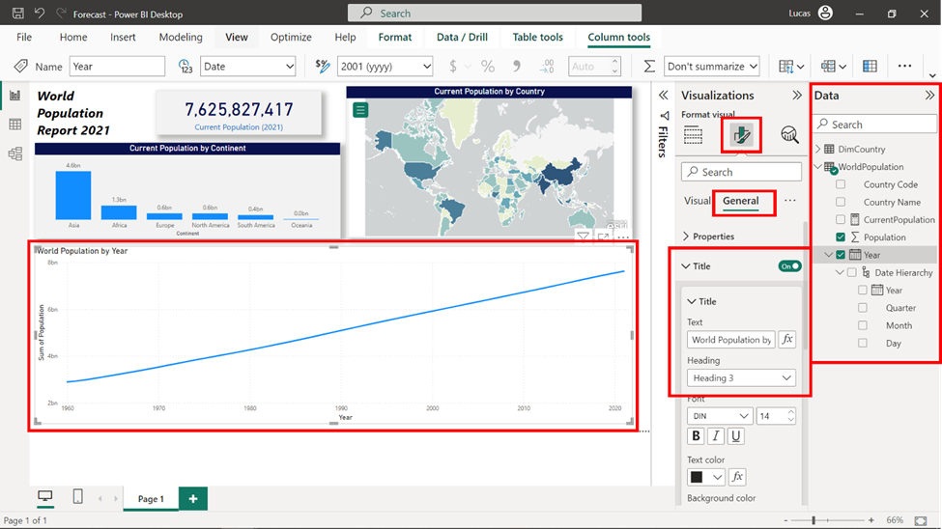

Now that the line chart has been added and formatted you can add the forecasts.

**Step 2: Enhancing the report with forecasting**

1. Select the line chart.
2. Open the **Analytics** tab which is located on the right side of the **Visualizations** pane.
3. Locate the **Forecast** tool in the **Analytics** pane list.
4. Turn the **Forecast** toggle to on. A forecasting line appears in the visualization.
5. Expand the **Forecast settings** section to access the forecasting line options.
6. Input **10** in the **Forecast length** field to incorporate a 10-year prediction on the visualization.
7. Select a **Confidence interval of** 95% to expand the upper and lower bounds of the prediction.
8. Select **Apply** to modify the forecasting line. Note the new resulting forecasting results by hovering over the forecasting line with the mouse.

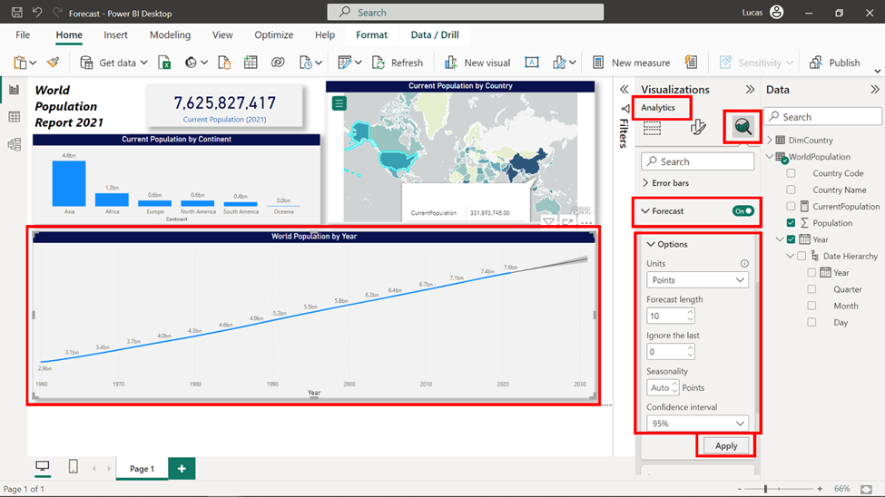

**Step 3: Customize the forecast line**

1. Scroll down below the **Options** settings for the forecast line in the **Analytics** pane.
2. Expand the **Forecast line** settings.
3. Modify the color of the line to blue so it adjusts with the rest of the report.
4. To keep the appearance solid, drop the transparency of the line to 50% so the forecasted plot stands out more.
5. In the **Confidence band** settings, modify the style to **Line** to change the forecast line’s bands into two additional lines that showcase the forecasted value's upper and lower bounds.
6. Last, on the **Tooltip title** field, enter **Population Forecast** as the **Title text** so that it is accurately displayed when hovering over the forecast line.
7. Note the new design and tooltip on the line chart’s forecasting line by hovering the mouse over it.

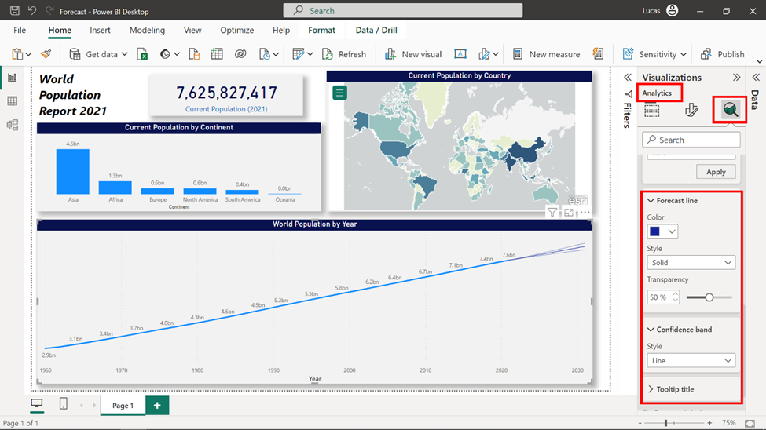

The output of your report after all your efforts should look like this:

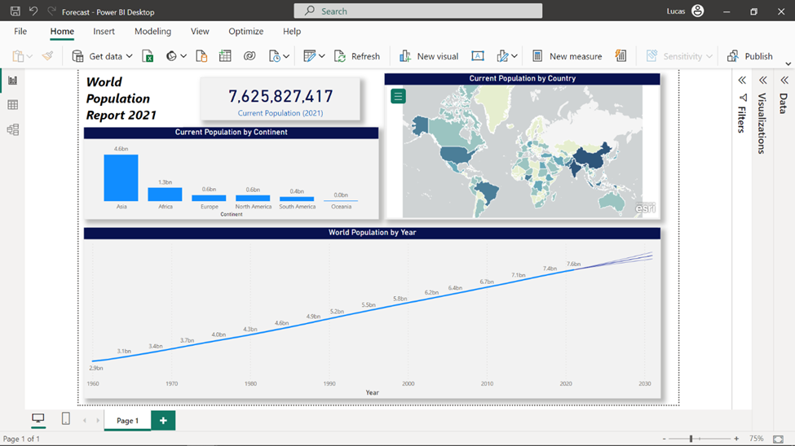

**Conclusion**

Well done for completing another activity. In this activity, you completed the vacant section at the bottom of a report by harnessing Power BI's forecasting capabilities. In doing so, the report now offers a glimpse into the projected world population for the next 20 years, adding a valuable dimension to the analysis.